

Level 1 Bivariate investigation

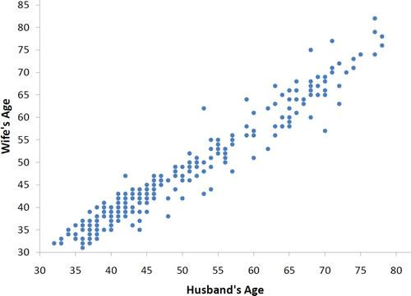

## Name:



**By Liz Sneddon**

### Problem / Plan

## Example:

## Problem

I wonder if there is a relationship between a person’s foot length and hand span for students at Ormiston Senior College?

## Plan

For measuring foot length:

1. Ask the person to remove their right shoe.
2. Ask the person to place their right foot against a wall, facing outwards.
3. Make sure that their heel is touching the wall.
4. Place a book at the end of their toes.
5. Using a tape measure, measure the distance (in mm) from the wall to the bottom of the book.
6. Record this measurement on a data table.
7. Take measurements from 30 students.

For measuring hand span:

1. Ask the person place their right hand flat on a piece of paper on a desk, palm down.
2. Ask the person to spread their fingers as wide as they can.
3. Using a pen, mark the edge of the persons’ smallest finger and thumb.
4. The person can now remove their hand.
5. Using a tape measure, measure the distance (in mm) between the two marks.
6. Record this measurement on a data table.
7. Take measurements from 30 students.

## Exercises:

Look at the example plan and answer these questions.

1. Why would you ask the student to remove their shoe? Explain.
2. Does it matter whether you measure a student’s left or right foot? Explain why/why not.
3. Why do we record the measurement of the foot length in mm? Explain.
4. Why should we take measurements from people with small **and** big feet? (E.g. young and older people).
5. How long would it take to measure two students? How accurate would this be to estimate heights of other students?
6. How long would it take to measure all students at Ormiston Senior College? How accurate would this be to estimate heights of other students?
7. Circle the words that complete the sentences below.

Smaller sample sizes take a shorter / longer time to collect data, but are more / less accurate.

Larger sample sizes take a shorter / longer time to collect data, and are more / less accurate.

1. Why is measuring 30 students (rather than 2 or the whole school) a good compromise? Explain

## Exercises

**Problem 1**

I wonder if there is a relationship between a person’s **height** and **weight** for students at Ormiston Senior College?

**Plan**

State what the two variables you are investigating are.

Then write a detailed plan of how you are going to take these measurements.

**Measure Variable 1:**

**Measure Variable 2:**

**Plan:**

**Problem 2**

I wonder if there is a relationship between the **distance** a student walks to school and the **time** it takes to walk from home for students at Ormiston Senior College?

**Plan**

State what the two variables you are investigating are.

Then write a detailed plan of how you are going to take these measurements.

**Measure Variable 1:**

**Measure Variable 2:**

**Plan:**



### Data

You will need to measure and record the data for your investigation. You will need to set up a table similar to the one below.

|  |  |  |
| --- | --- | --- |
| **Sample** | **Measurement 1** | **Measurement 2** |
| 1 |  |  |
| 2 |  |  |
| 3 |  |  |
| … |  |  |
| 30 |  |  |

### Analysis

#### Drawing Scatter Graphs

You will be using NZGrapher to draw a graph of your data.

## Exercise:

Go to NZGrapher and explore one of the following two datasets. Then choose two quantitative variables and draw a scatter graph. 

1. Diamonds.csv

2. Rugby.csv

#### Analysing Scatter Graphs

|  |  |
| --- | --- |
| **Step 1:**  Draw edges around the data points (like joining the dots) | **Step 2:**  Think of the data in the middle as a paintbrush stroke. |

## Exercise:

Shade in the following graphs.

|  |  |
| --- | --- |
|  |  |
|  |  |

#### 

#### Trend

|  |  |  |
| --- | --- | --- |
| a **linear** trend…  (looks like a straight line, and has a constant step size) | a **non-linear** trend…  (looks like a curve and has a **non-constant** step size) | or **no** trend?  (no pattern at all) |
|  |  |  |

## Direction

|  |  |
| --- | --- |
| a **positive** direction…  (as one measurement gets bigger, so does the other) | or a **negative** direction?  (as one measurement gets bigger, the other gets smaller) |
|  |  |

#### Scatter

|  |  |  |
| --- | --- | --- |
| a **strong** relationship?  (small amount of scatter) | a **moderate** relationship?  (moderate amount of scatter) | **or** a **weak** relationship?  (a lot of scatter) |
|  |  |  |

## Exercise:

1. Shade the data. Then decide whether there is a relationship between variable A and B. If there is a relationship, decide the trend, direction and strength.

|  |  |
| --- | --- |
|  | **Relationship**:  Yes / No  **Trend**:  Linear / Non-linear  **Direction**:  Positive / Negative  **Strength**:  Strong / Moderate / Weak |
|  | **Relationship**:  Yes / No  **Trend**:  Linear / Non-linear  **Direction**:  Positive / Negative  **Strength**:  Strong / Moderate / Weak |
|  | **Relationship**:  Yes / No  **Trend**:  Linear / Non-linear  **Direction**:  Positive / Negative  **Strength**:  Strong / Moderate / Weak |
|  | **Relationship**:  Yes / No  **Trend**:  Linear / Non-linear  **Direction**:  Positive / Negative  **Strength**:  Strong / Moderate / Weak |
|  | **Relationship**:  Yes / No  **Trend**:  Linear / Non-linear  **Direction**:  Positive / Negative  **Strength**:  Strong / Moderate / Weak |
|  | **Relationship**:  Yes / No  **Trend**:  Linear / Non-linear  **Direction**:  Positive / Negative  **Strength**:  Strong / Moderate / Weak |

**Example:**

|  |  |  |
| --- | --- | --- |
|  |  |  |

I notice that the **trend** of relationship between the age of a student and their height appears to be **linear**. This is because the trend is **changing at a constant rate**.

|  |  |  |
| --- | --- | --- |
|  |  |  |

I notice that the **direction** of relationship between a students age and height is **positive**. This is because as age **increases**, height **increases**.

|  |  |  |
| --- | --- | --- |
|  |  |  |

I notice that the **strength** of relationship between a students age and height is **weak**. This is because there is **a lot of scatter** around the trend line.

**Exercise:**For the following graphs, shade the data, then describe the **features** (trend, direction and strength) in **context**.

1. **Problem:**

I wonder if there is a relationship between the age (years) of school students and the length of their right foot, for a sample of students in NZ.

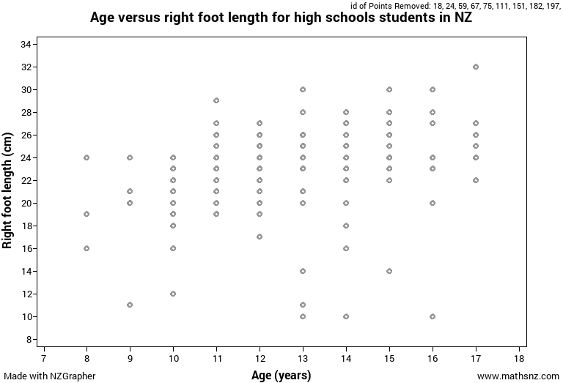

1. **Problem:**

I wonder if there is a relationship between the age (years) of school students and the length of their right foot, for a sample of students in NZ.

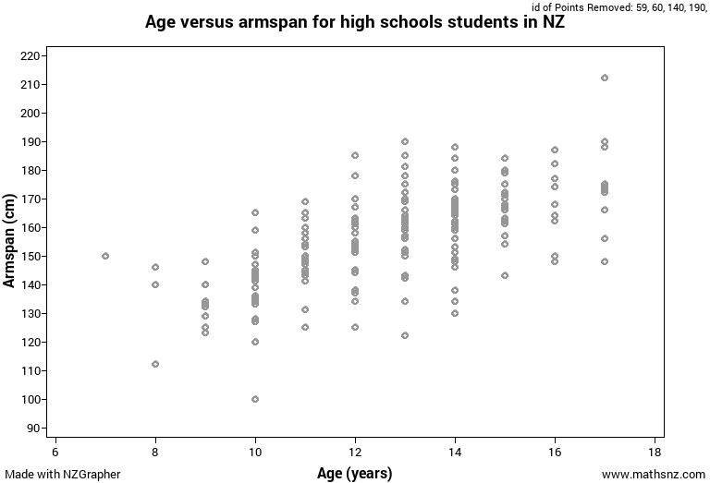

1. **Problem:**

I wonder if there is a relationship between the age (years) of school students and the length of their right foot, for a sample of students in NZ.

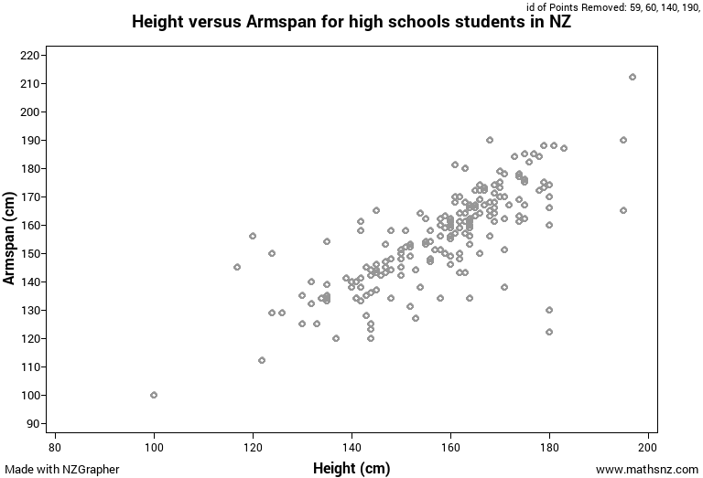

1. **Problem:**

I wonder if there is a relationship between the age (years) of school students and the length of their right foot, for a sample of students in NZ.

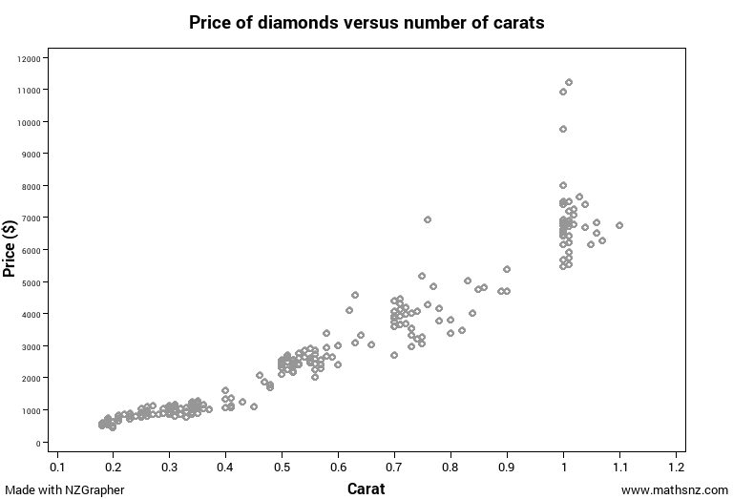

1. **Problem:**

I wonder if there is a relationship between the age (years) of school students and the length of their right foot, for a sample of students in NZ.

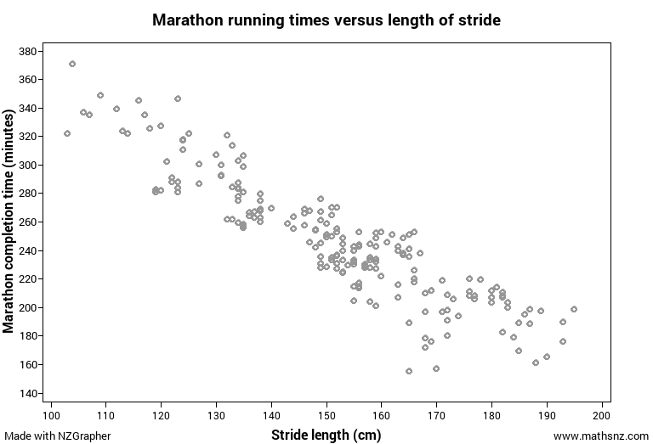

#### Adding a line of best fit

We want to draw a line that represents the data well. This means a line going through the middle of the data.

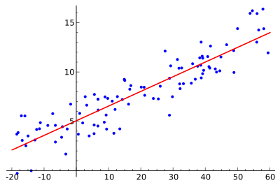

## Exercise:

1. Which of the following lines best fits the data? Explain.

|  |  |  |
| --- | --- | --- |
|  |  |  |

2) Add a line of best fit to the following graphs.

|  |  |
| --- | --- |
|  |  |
|  |  |
|  |  |



### Conclusion

In your conclusion you need to:

* Answer the investigation problem
* Discuss which population the results apply to
* Discuss Sampling Variability

**Answering the investigation problem**

When making a conclusion, we need to decide if there is a relationship or not between the 2 measurements.

**Population**



The conclusion is valid for the specific population that has been sampled.



The conclusion can only be applied to an identical population of the one for which the data was collected.

## Example:

If the data is of Americans, then the conclusions can only be applied to other Americans.

It may be that there are sufficient similarities in the population of America and NZ for the data to be useful to help offer guidance.

**Sampling variability**



If I took another sample …

* When another sample is taken, you will select different people, therefore your data will differ from sample to sample.
* However, if a difference is present (or not) in the population, then each sample should represent this
* This means that the analysis and conclusion are likely to remain the same.

If I took a bigger sample …

* The data will be more representative of the population.
* The results will be more accurate.
* The conclusion will be more accurate, and therefore the relationship (if one exists) is stronger.
* Also weaker relationships are more able to be detected with a large sample than a small sample.

## Example:

Data was collected from a sample of students at Ormiston Senior College. These 30 students measurements are shown on the graph below. An analysis and conclusion are given below.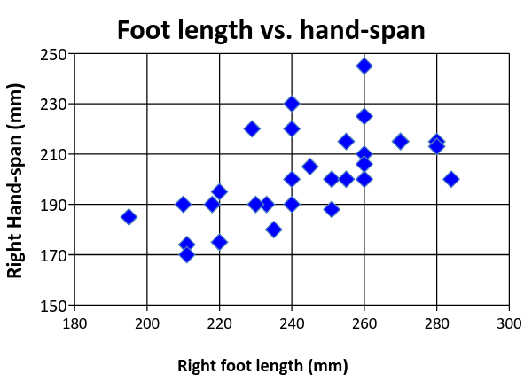

Therefore I can conclude that there is a relationship between the right foot length and right hand span for students at Ormiston Senior College.

I notice that there is a linear, positive, weak relationship between the right foot length and right hand span.

The relationship between right foot length and right hand span is linear because the right foot length is increasing at a constant rate. For every 1 mm increase in right foot length, the right hand-span is increasing by approximately 0.5 mm.

The analysis and conclusion can be applied to all students at Ormiston Senior College. These results may also be applied to other senior students across New Zealand, as I would expect the foot length and hand-span to be similar across most students in New Zealand.

These results may not be applied to younger children, as they may have different ratios of hand span and foot length as they have many different growth spurts.

If I took another sample, I would expect different data (as I would be measuring different students), but I would expect the analysis and conclusion to be similar. I would still expect to see a positive, weak, linear relationship between right foot length and right hand span.

If I took a bigger sample, I would expect data that was more representative of the population, and therefore more accurate. This means that the foot lengths and hand spans that we measured of students at Ormiston Senior College, and the line of best fit is more accurate as we are better at estimating where the line should go. Hence the relationship between foot length and hand span would be stronger.

## Exercise:

Write a conclusion for each of the problems below.

**1) Problem:**

I wonder if there is a relationship between the age (years) of school students and the length of their right foot, for a sample of students in NZ.



**2) Problem:**

I wonder if there is a relationship between the age (years) of school students and the length of their right foot, for a sample of students in NZ.



**3) Problem:**

I wonder if there is a relationship between the age (years) of school students and the length of their right foot, for a sample of students in NZ.



**4) Problem:**

I wonder if there is a relationship between the age (years) of school students and the length of their right foot, for a sample of students in NZ.



**5) Problem:**

I wonder if there is a relationship between the age (years) of school students and the length of their right foot, for a sample of students in NZ.





## 

Fill in the planned completion dates, and when you have finished each Key skill, show your teacher so they can track your progress.

|  |  |  |  |
| --- | --- | --- | --- |
| **Key Skill** | **Workbook pages** | **Planned Completion Date** | **Completion Date (teachers sign)** |
| Problem /  Plan /  Data | 2 - 6 |  |  |
| Analysis | 7 - 19 |  |  |
| Conclusion | 20 - 27 |  |  |